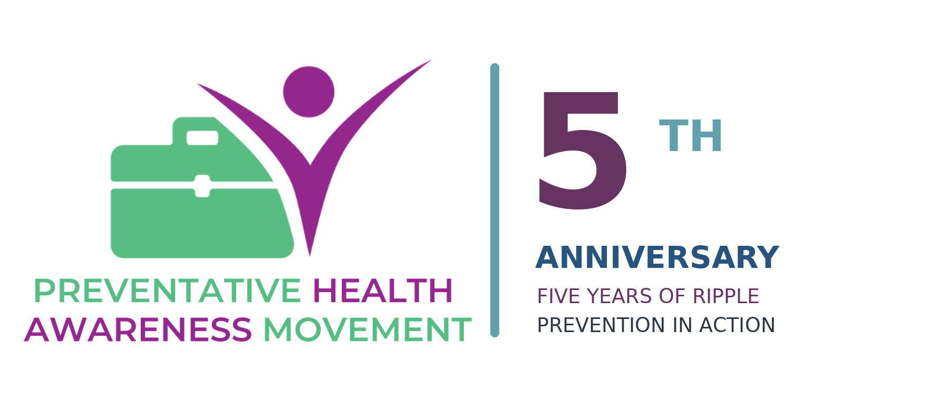
2027 PARTNERSHIP & SPONSORSHIP INVITATION
BUILD YEAR FIVE WITH US
A pivotal year for a grassroots movement putting prevention into action.
THE INVITATION
For five years, PHAM has been creating ripples - bringing practitioners, patients, communities, media and leaders together around prevention, health literacy, collaboration and patient empowerment. In 2027, we are inviting aligned organizations to help us make the ripple bigger.
Five years of prevention. Five years of collaboration. One bigger conversation.
February 2027 • Georgetown → Communities Across Canada

2027 PARTNERSHIP
PROSPECTUS
THE STORY

Five Years of Ripple
PHAM began in Georgetown, Ontario with a simple but ambitious belief: we cannot build healthier communities by waiting until people are sick.
What started as a grassroots movement has grown into a collaborative network of more than 100 PHAMbassadors and healthcare professionals, with practitioners raising their hands across Canada and beyond to share expertise, learn from one another and help break down the silos that too often fragment care.
Along the way, PHAM has created community events, public education, podcast and television conversations, government engagement, interdisciplinary relationships and a collaborative book bringing multiple healthcare voices and lived experience together.
WHAT WE ARE MOST PROUD OF
PHAM has not spent five years simply talking about prevention. We have been putting prevention into action - in communities, through relationships, through education, and by creating bridges between professionals who may never otherwise have learned from or referred to one another.

Why 2027 is different
Our fifth anniversary arrives as prevention, person-centred care, patient participation and collaboration are receiving renewed national attention. PHAM does not claim government endorsement. We do believe five years of grassroots experience gives us real stories, practical lessons and community voices worth bringing to the larger conversation.
When we break down silos between healthcare professionals, the person who ultimately benefits is the patient.

2027 PARTNERSHIP
PROSPECTUS
THE YEAR AHEAD

2027: Prevention in Action
February 2027 will be PHAM's most ambitious Preventative Health Awareness Month yet - a month designed to celebrate what has been built, bring the movement home, and create a platform for the next five years.
PHAM AT FIVE • GEORGETOWN LAUNCH
A special opening experience in the community where PHAM began, bringing patients, practitioners, community leaders, partners and supporters to the same table.

THE ART OF PREVENTION
A participatory art installation that asks communities to visually express what prevention and health mean to them - with a call to action for other communities to create their own.

COMMUNITY FLAG CAMPAIGN
Build on previous municipal flag raisings and work toward doubling the number of communities visibly recognizing Preventative Health Awareness Month.

SIGNATURE PREVENTION EVENTS
Interactive programming across the pillars of wellness and focus days, including mental health and addiction prevention, midlife health, movement, healthy aging and other community priorities.

BECOME THE CEO OF YOUR HEALTH • ON THE ROAD
The podcast and public-education platform will travel into communities, capturing real conversations and bringing prevention closer to where people live, work and gather.

WHAT'S THE BUZZ ABOUT?
A road campaign designed to make prevention visible, approachable and shareable - with the ambition of collaborating with a mobility partner such as Volkswagen Canada and other aligned organizations.

2027 PARTNERSHIP
PROSPECTUS
PARTNERSHIP PHILOSOPHY

We are looking for partners, not just sponsors
Financial investment matters. So do vehicles, venues, accommodation, production, printing, technology, food, media reach, professional expertise and the relationships that help a grassroots idea travel farther.
The best PHAM partnerships will be built around shared values and meaningful impact - not simply logo placement.
OUR 2027 CASH GOAL
PHAM is working toward a minimum of $25,000 in cash sponsorship, with a stretch goal that allows the fifth anniversary to grow beyond a single month and create lasting infrastructure for the movement.

What partner investment can help make possible
- Community launch and signature events throughout February.
- Expansion into more municipalities and community activations.
- The Art of Prevention and its community replication toolkit.
- The What's the Buzz About? road campaign and travelling media production.
- Accessible, evidence-informed public education and event resources.
- Podcast, video, photography and storytelling that extend impact beyond the room.
- Travel and hospitality that allow PHAMbassadors and expert voices to participate.
- Evaluation and a Year Five impact report that documents what was learned.
Don't just put your logo on the ripple. Help create it.

2027 PARTNERSHIP
PROSPECTUS
BUILD YEAR FIVE WITH US

Partnership Levels
Every contribution matters. We have intentionally created entry points for local businesses, individuals, community champions and national organizations.
$250 | RIPPLE SUPPORTER  A welcoming entry point for individuals and small businesses who want to help move prevention forward.  Name listed on the PHAM at Five digital supporter page • Year Five supporter graphic for social sharing • Recognition in the Year Five community thank-you

$500 | COMMUNITY SUPPORTER  For local organizations and community champions who want to visibly stand behind PHAM at Five.  Community Supporter recognition online • Name/logo on selected community thank-you materials • Social-media group recognition • Year Five supporter graphic

$2,500 | COMMUNITY PARTNER • BRONZE  Help bring PHAM programming and prevention conversations into communities.  Logo recognition on PHAM at Five partner materials • Website recognition • Launch/event recognition • Group social recognition • Year Five impact report recognition

$5,000 | IMPACT PARTNER • SILVER  Support multiple Year Five activations and help extend PHAM's reach.  Enhanced logo placement • Individual recognition • Selected February activation recognition • One partner story/activation • Road-campaign recognition where appropriate

$10,000 | LEGACY PARTNER • GOLD  A major investment in the fifth anniversary and the next chapter of the movement.  Premier Year Five recognition • Dedicated partner spotlight • Prominent event recognition • Selected road/media integration • Up to two content opportunities

2027 PARTNERSHIP
PROSPECTUS
PREMIER OPPORTUNITY

Founding Fifth Anniversary Partner
$20,000 - $25,000
A limited premier partnership for an organization that wants to help shape the scale of PHAM's pivotal fifth year and be visibly associated with the movement's largest anniversary campaign to date.
POSITIONING
Founding Partner of PHAM's Fifth Anniversary • Five Years of Prevention in Action

Potential benefits
- Premier brand recognition across PHAM at Five materials and key anniversary activations.
- Prominent association with the Georgetown launch, signature events and Year Five storytelling.
- Integration into the What's the Buzz About? road campaign where strategically aligned.
- Recognition across selected Become the CEO of Your Health podcast/TV/video content.
- Opportunity to co-create an appropriate employee or community preventive-health activation.
- Premier recognition in the Year Five impact report and anniversary recap.
- Category exclusivity may be negotiated where appropriate.
- Custom activation opportunities developed collaboratively and subject to PHAM's health-education and editorial guardrails.
IMPORTANT CREDIBILITY BOUNDARY
Sponsorship does not purchase clinical claims, patient data, editorial control, guaranteed speaking roles or influence over health-education content. PHAM retains responsibility for the integrity of its programming.
A founding partner isn't funding one event. They are helping scale five years of prevention in action.

2027 PARTNERSHIP
PROSPECTUS
COMMEMORATIVE & IN-KIND PARTNERSHIPS

Make the Fifth Year Visible

Official Flag & Fifth Anniversary Commemorative Partner
PHAM is grateful to have support developing for the tangible symbols of Year Five: community flags and commemorative swag. These items help make the movement visible and give PHAMbassadors, community leaders and participants something meaningful to carry forward.
FLAG PARTNER
Support production and expansion of the PHAM community flag campaign. Sponsor recognition lives around the campaign and its storytelling - while the PHAM flag itself remains clean and movement-led.
FIFTH ANNIVERSARY COMMEMORATIVE PARTNER
Support limited-edition PHAM at Five items such as pins, apparel, totes, notebooks, water bottles or other keepsakes. We want these pieces to feel collectible and meaningful, not disposable promotional merchandise.

In-Kind & Strategic Partners
Mobility Partner: Vehicle, wrap, fuel/charging, maintenance or transportation for the What's the Buzz About? road campaign.
Hospitality Partner: Accommodation and travel support for PHAMbassadors, experts and travelling production.
Venue Partner: Community spaces for the Georgetown launch and other activations.
Art of Prevention Partner: Artist fees, materials, fabrication, installation, transport or community replication.
Media & Production Partner: Video, podcast, livestream, photography, editing, AV or broadcast support.
Print & Signage Partner: Passports, posters, educational materials, event signage and campaign collateral.
Food & Event Hospitality Partner: Catering, refreshments and event-hosting support.
Accessibility Partner: Captioning, interpretation, transportation or other supports that help more people participate.
HOW WE VALUE IN-KIND SUPPORT
In-kind contributions are valued at the real cost they replace for PHAM, not an inflated retail or promotional value. Recognition is customized to the contribution and its relevance to the campaign.

2027 PARTNERSHIP
PROSPECTUS
THE INVITATION

Help us create the next ripple
Five years ago, PHAM began with people willing to believe in an idea before anyone knew how far it could travel.
Today, practitioners are learning from one another, communities are raising flags, Canadians are joining conversations about their health, and PHAM is building new ways to connect evidence, lived experience, professional expertise and everyday action.
Our fifth anniversary is a celebration - but more importantly, it is a launchpad.
WE WOULD LOVE TO TALK
Whether your organization is considering a $250 community contribution, a major national partnership, an in-kind collaboration or a creative idea we have not yet imagined, we would welcome the conversation.
Come to the table. Join the movement. Help us change the legacy of healthcare - together.
PHAM AT FIVE
FIVE YEARS OF RIPPLE • PREVENTION IN ACTION
Partnership conversations: Margaret Wallis-Duffy
Founder, Preventative Health Awareness Movement
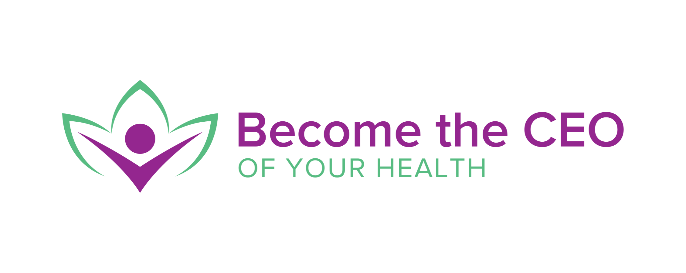
Georgetown → Canada → Beyond

